INTRODUCTION:
Some special type of structures like cooling towers , bunkers and silos are considered as continuous systems. These type of structures have importance in their functionality. Some of the continuous systems may have different type of profiles like rectangular, trapezoidal, hyperboloid etc. Their response due to dynamic loading varies for different profiles
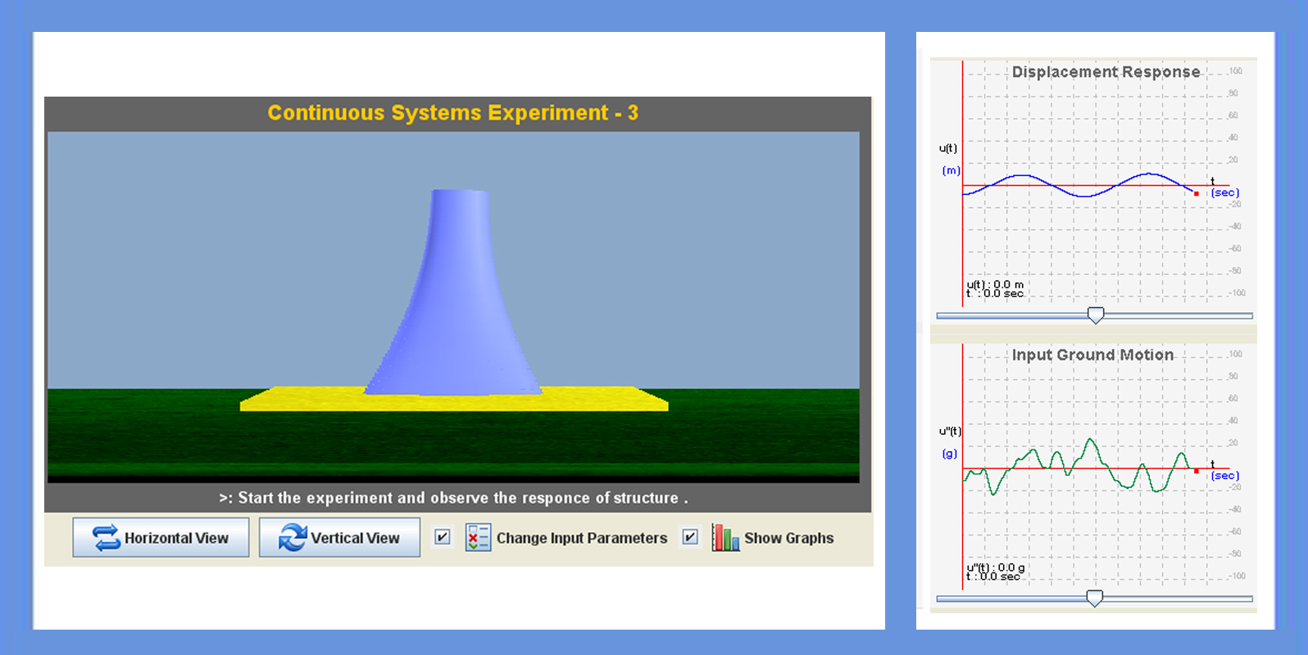

THEORY:

The continuous systems are more complex systems for doing their analysis. So for developing analysis of this complex system, we will treat it as SDOF system which usually calls as generalized SDOF systems.
Equation of motion for a generalized SDOF system is,

where,

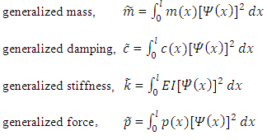
and = shape function
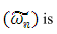
Natural frequency of the system

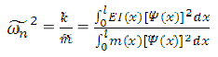
Finally the deflection of the system at any level of height can be related by using,
Where z(t) = generalized displacement, = shape function

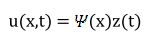

OBJECTIVE:

To know the response of structure for different profiles and for different behavior (shear(fixed), bending, shear(hinge)) of the structure.

MANUAL:
Start the experiment with given values of structure and with given earthquake data. Observe the response of structure for different type of profiles.
Stage 1:
While coming to this stage, user can be able to change behavior of structure and its height. Observe the response of structure with modified parameters.
Stage 2:
In this last stage, user will change all the displayed parameters. User can observe the response of structure at different level in its height.

PART - 2
ANIMATION STEPS
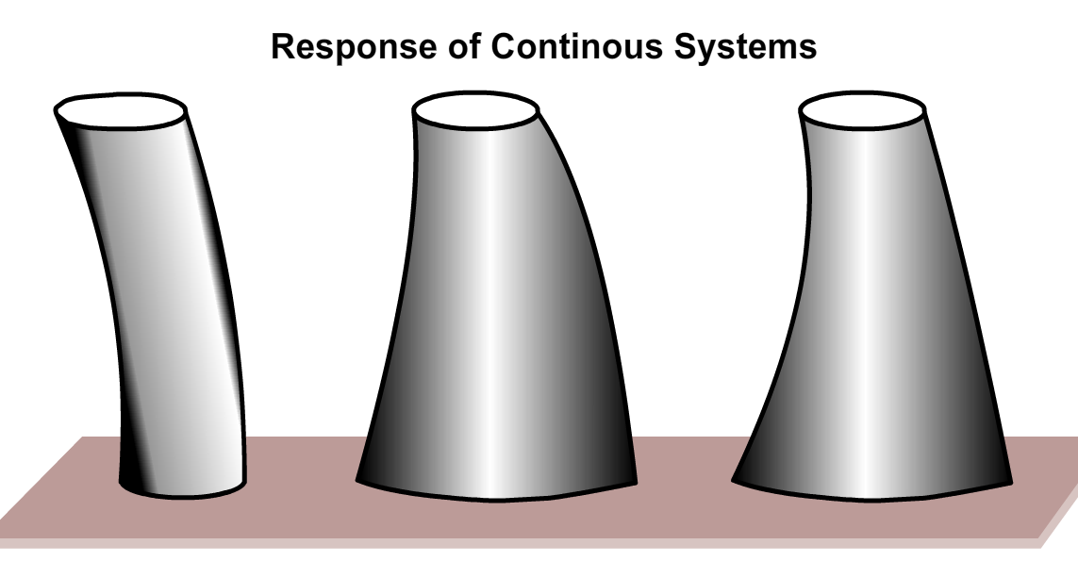

PART – 3
VIRTUAL LAB FRAME
